APRIL 2017

Protecting integrity: 2016 council elections



## Local Government Investigations and Compliance Inspectorate

# Table of contents

1. **Introduction**
2. **Our role in the 2016 council elections**
3. **2016 elections complaints data and themes**

**10 Pre-election work – what was achieved?**

**10 Election period policy review**

**13 Candidate eligibility review**

1. **Local government laws for media during elections**
2. **Campaign donation returns**
3. **Appendix A: Complaints and relevant Act provision**

Authorised by the Victorian Government, 1 Spring St, Melbourne

Contact us if you need this information in an accessible format,

please telephone 1800 469 359 or email inspectorate@lgici.vic.gov.au. This document can also be found in PDF and Word formats on our website www.lgici.vic.gov.au

# Introduction

David Wolf, *Chief Municipal Inspector*



## The general council elections, part of the four-year council term, is a vibrant time for local government in Victoria and is equally vibrant for the Local Government Investigations and Compliance Inspectorate as the dedicated integrity agency for councils.

It is during this period that my office has responsibility for protecting the integrity of local government, and in this case the 2016 council elections, which includes oversight of councils, councillors, candidates and voters subject to the electoral laws under the *Local Government Act 1989*. This responsibility includes guidance and education for participants in the process, applying a proactive approach to resolving potential issues, and providing an avenue for complaints to be made and addressing those matters.

A core competency for any integrity agency is to efficiently and effectively address complaints in consideration of the expectations from the source of the complaint and the parties involved. This is particularly relevant in the compressed timeframe of an election period where complaints and any actions of the integrity agency can have significant impact on the results. It is also challenging when, in the Inspectorate’s case, the complaints received in the election period represent a 100% increase on what is usually received over the course of a non-election year.

In the 2016 election period alone, my office assisted with more than 2000 enquiries and received 409 formal complaints for matters ranging from minor campaign material offences to serious corruption allegations for activities intending to undermine the democratic system. The exceptional work of my office resulted in 96% of those complaints being receipted, assessed and action taken within two working days to largely resolve matters with no basis, genuine mistakes, or issues that did not present a high-risk in terms of offending the system.

This performance effectively eliminated the ability for the complaints process to be used as a campaign tactic for those seeking to do so.

The Inspectorate completed three key pieces of work in the lead-up to the elections, focusing on informing key participants and enforcing provisions before the ballots took place. The results of this work contributed to reductions in substantiated complaints relating to council [public] resources being used for campaigning, reductions in complaints about media outlets and also the removal of two candidates from their respective ballots for breaching the qualification provisions. All of these important outcomes support fair and transparent elections.

While my office has the primary responsibility for the integrity of the election period, the role of the Victorian Electoral Commission (VEC) as the sole agency managing the conduct of the election is also significant. It is important to recognise the outstanding collaboration with the VEC in preparing for and throughout the election period and I thank Commissioner Gately and his staff for their work.

I also would like to acknowledge the assistance of the 78 participating councils, Victoria Police and the Independent Broad-based Anti-corruption Commission (IBAC) for their assistance on specific matters as they arose.

I am pleased to publish this report as an insight to the key integrity issues, challenges and outcomes for the 2016 general council elections in Victoria.

# Our role in the 2016 council elections

## As the leading integrity agency for Victorian councils, the Inspectorate’s role in council elections extends far beyond the closing of the official election period. Preparation work for the 2016 elections commences more than 12 months earlier and continues well after the election day.

To ensure a fair and democratic election process, the Inspectorate’s broad responsibilities include: monitoring candidate eligibility; providing advice to and monitoring the conduct of councils and candidates; receiving and assessing allegations; and conducting investigations into potential offences under the *Local Government Act 1989*.

The council election period commences on the last day nominations are accepted by the VEC, and ends at 6pm on election day. The 2016 election period commenced Tuesday 20 September and ended 22 October.

While 409 formal complaints were lodged during the election period, the Inspectorate worked proactively to resolve in excess of 2000 enquiries, removing the necessity for formal complaints to be submitted. It also ensured new electoral provisions were followed through with guidance and education provided to the sector, further strengthening the integrity of the system.

Following the 2012 elections, the Inspectorate made submissions to the Local Government Electoral Review which resulted in amendments to the Act*.* The changes set higher standards for candidate eligibility, candidate nomination procedures and provided clarifications of the use of council resources during an election period.

As part of the 2016 pre-election work, including monitoring the implementation of key legislative changes, it was important for the Inspectorate [as an integrity agency] to appropriately prepare by:

* developing and implementing processes to deal with increased number of complaints in a timely manner
* increasing staff to be able to undertake all the functions during the election period
* conducting a review of councils’ election period policies
* entering into a Memorandum of Understanding (MOU) and working in collaboration with the VEC
* strengthening relationships with other key regulatory organisations such as Victoria Police and IBAC
* assessing and reporting on candidate eligibility
* building two-way communication with media outlets.

This report provides an overview of the complex and varied work carried out by the Inspectorate during the 2016 election period, along with an analysis of the key outcomes.

# 2016 elections complaints data and themes

## During the election period, the Inspectorate answered more than 2000 enquiries and received 409 formal complaints. This represents a slight increase on comparative complaints from the 2012 election period.

As a complaints-based agency, it is important that members of the community know how to lodge complaints, know how to seek advice and know what constitutes a valid complaint. The rise in enquiries and formal complaints is a positive indicator that the community feels comfortable raising issues with the Inspectorate and is increasingly aware of the integrity agency’s role.

It is important to note that elections in Australia allow for robust political debate and the expression of opinion. Therefore, it is vital that complaints are received, assessed and dealt with swiftly to ensure fair and transparent elections, and the opportunity for the complaints process to be manipulated as a campaign tool is minimised. This is especially relevant for complaints that are without basis, not in good faith and are low-risk offences caused by a lack of understanding, or a genuine mistake.

Moreover, it is critical that substantive matters, that carry a risk to the system, are identified and appropriately investigated to determine the best outcome in consideration of the public interest.

The Inspectorate receives and addresses about 500 formal complaints in a non-election year on average, but during the 2016 election period alone, and with the responsibility for monitoring the electoral provisions of the Act, the Inspectorate fielded in excess of 2000 enquiries and received 409 formal complaints.

Those who reached out for guidance, information, or to lodge a complaint had varying degrees of involvement in the election and included councils, councillors, candidates, and voters. While not all complaints received related to an offence under the Act, each interaction was an opportunity for the Inspectorate to gather insight into emerging issues, identify trends and areas where education or legislation reform could contribute to higher levels of accountability and transparency at councils in Victoria. Table 1 shows the breakdown of complaint outcomes (noting that several matters are still under review and may progress to investigations).

*Table 1. Complaints categorised by outcome*

|  |  |
| --- | --- |
| **Complaint outcomes** | |
| No offence – matter closed | 249 |
| No offence – advice provided | 61 |
| Not in jurisdiction | 6 |
| Referred to other agency | 6 |
| Offence – no action taken | 13 |
| Offence – advice provided | 14 |
| Offence – warning issued | 39 |
| Transferred to investigation team | 21 |
| **TOTAL** | **409** |

#### Complaints data analysis

In an overall comparison to the 2012 election period there was a slight increase in complaint numbers. In 2016, like 2012, complaints about candidate election campaigns were more common than any other single issue, representing 48% of the total number of complaints.

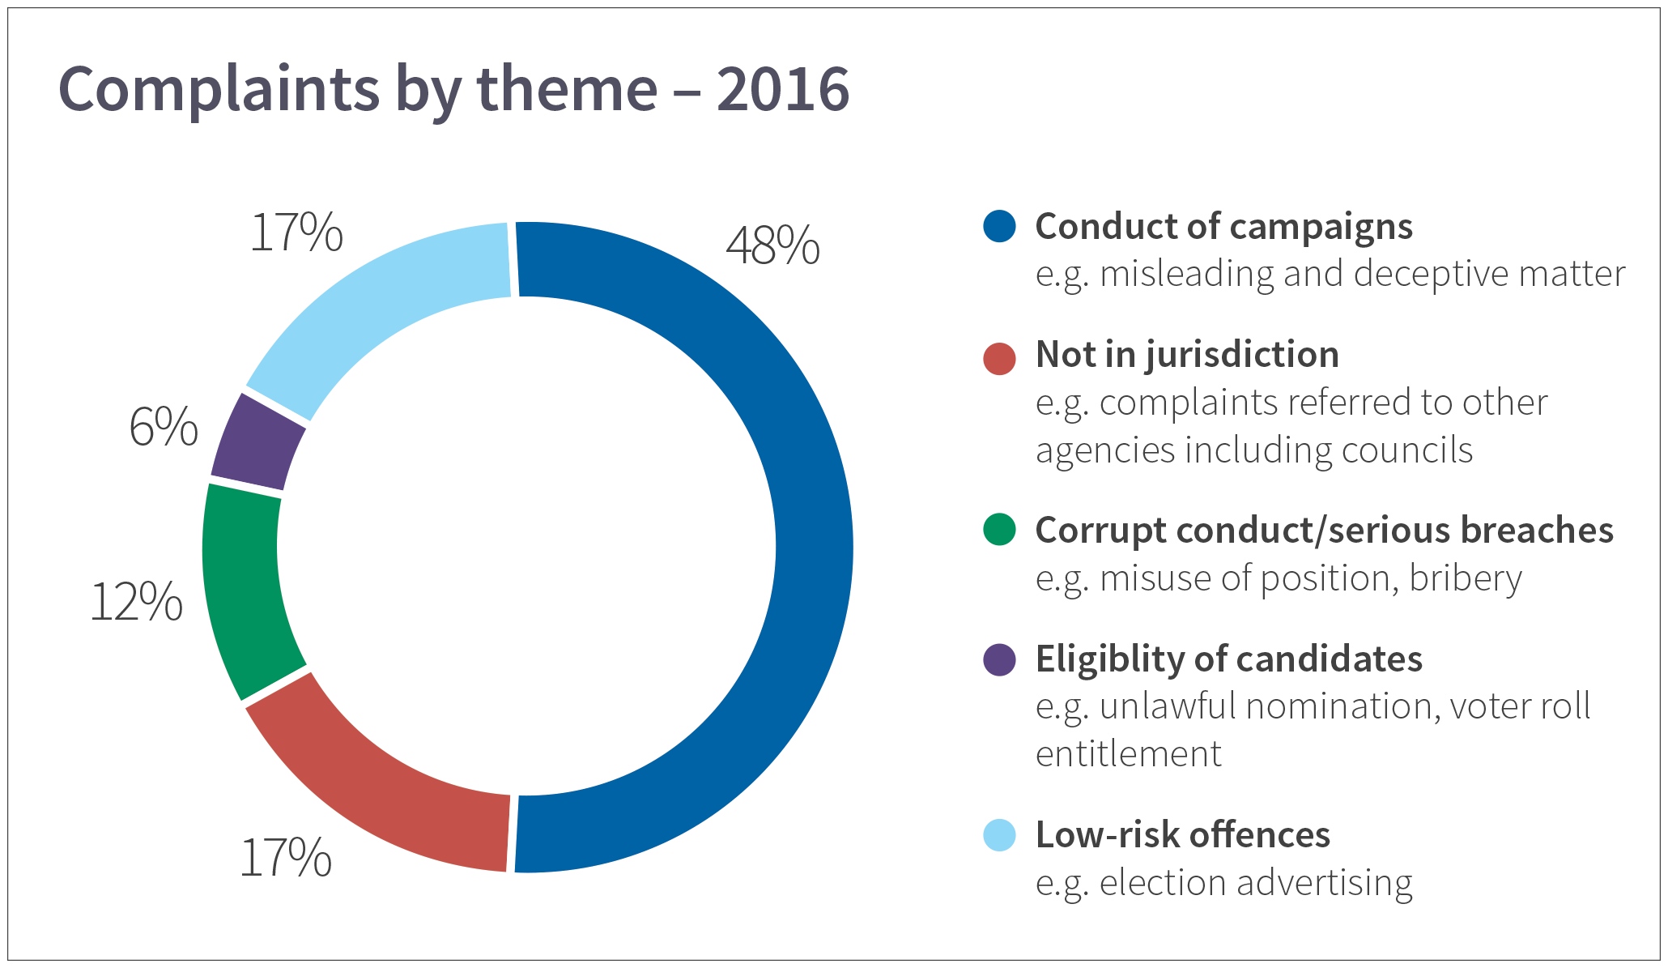

*Figure 1. Complaints by theme for 2016*

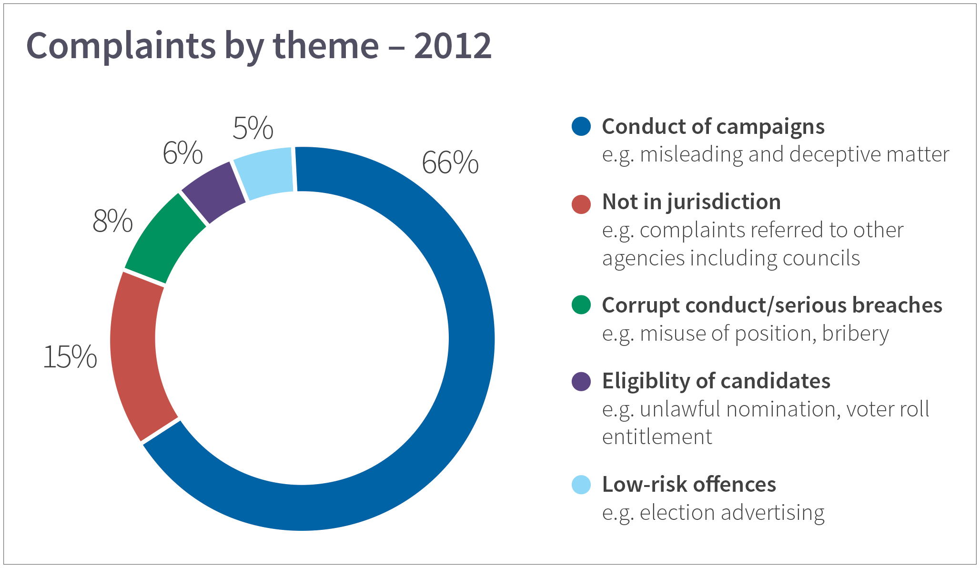

*Figure 1. Complaints by theme for 2012*

#### Our performance

The Inspectorate’s assessment process focussed on: identifying complaints that had no foundation; providing advice; providing guidance or warnings for low-level matters; and/or escalating those with grounds to warrant further investigation and that presented risk of serious offences or risk to the electoral system itself.

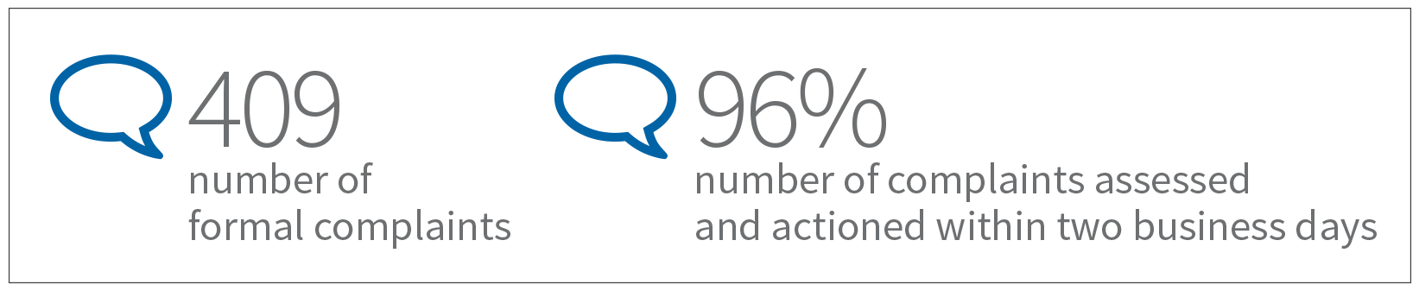

**Processing of complaints is important**

The importance of receiving, assessing and dealing with complaints during an election period cannot be overstated. It is fundamental to the integrity and transparency of elections because the actions of the individual involved, the response by the integrity agency, and the reporting by media may have potent influence during an election period.

Following the 2016 council elections in Queensland, the Crime and Corruption Commission, (CCC), which has the responsibility for local government integrity in Queensland, experienced a rise in election complaints as well as complaints being reported by media outlets.

Following this rise, the CCC produced data to indicate that “a large number of allegations received by the office are baseless and merely designed to effect electoral damage on political opponents”1. The CCC then proposed a legislative a ban on media reporting of complaints and their investigation during future Queensland election periods.

While legislation is an important and necessary tool in maintaining the integrity of elections, a proposed ban on media reporting should only be considered as a last resort due to the impact on transparency and the cost of greater regulation on the public. The Inspectorate has shown through its work that having a dedicated integrity agency for this sector, effective education, appropriate resources, risk identification and early resolution is a preferred model.

#### What was up, what was down and why?

**Authorisation of election material**

One hundred and twenty-two complaints alleged failures to comply with the election material authorisation provisions of the Act, which require the authoriser’s name and address to appear at the end of the material. The intent of this requirement is to provide a way for voters to access the source of the information and allow an opportunity to question representations made. The majority of these complaints related to the absence of any authoriser’s details, however, this was not the only issue raised. Complainants also questioned the content and validity of authorisations with allegations that addresses provided were not the valid addresses of the author, or the author was not an *actual* person.

Following initial enquiries by the Inspectorate, it was found that in 55 of the 122 cases an offence was substantiated and in most cases compliance was requested and achieved. The Inspectorate found that it was not in the public interest to further investigate for the purpose of prosecution, given the low-risk nature. Greater value was placed on providing guidance and educational material. In 36 cases, formal warnings for the offences were issued.

In 2012 there were 85 complaints of this nature, which shows that there was a 43% rise in this area of complaints in 2016. This may be a result of the changes in technology and the rise of candidates increasingly using social media channels to influence the community during the election period. Social media, its impact, and whether the current legislation takes the changes in technology into consideration, will be discussed later in this report.

*1 Publicising allegations of corrupt conduct: Is it in the public interest? 12 December 2016 [http://www.ccc.qld.gov.au/news-and-media/ccc-media- releases/ccc- recommends-limitation-on-publicising-allegations-of-corrupt-conduct-during-local-government-elections-12-december-2016](http://www.ccc.qld.gov.au/news-and-media/ccc-media-%20releases/ccc-%20%20recommends-limitation-on-publicising-allegations-of-corrupt-conduct-during-local-government-elections-12-december-2016)*

**Misleading and deceptive matter**

Another allegation theme that emerged during the elections was complaints about misleading or deceptive matter. Sixty-nine complaints contained allegations about campaign material or statements that contained misleading or deceptive matter. Many complaints disputed the accuracy of statements made by other parties in material published either by themselves, or other candidates.

Section 55A of the Act states that a person must not print, publish or distribute any matter including: electoral advertisements; handbills; pamphlets or notices that contain a representation of a ballot-paper to be used in an election that is likely to mislead or deceive a voter in the casting of their vote. The table below highlights examples from complaints about misleading and deceptive matter, grouped under common themes.

*Table 2. Key examples of complaints about misleading and deceptive matter*

|  |  |  |
| --- | --- | --- |
| **Overall theme Allegation** | | |
| Use of the term ‘councillor’ in election material To mislead voters, a candidate referred to themselves as a councillor  in a leaflet sent to residents to make it look like they were being endorsed by council | | |
| Images or tex is endorsed b | t which incorrectly implied candidate y, or is a member of, a political party | To mislead voters, a candidate used certain terms in an electoral poster to make it look like they were being endorsed by one political party |
|  | | Another complaint about newspaper coverage claimed the reporter deliberately left out the candidates’ political party affiliations |
| False statements about achievements as a councillor | | Complaint made in a candidate statement where a candidate referred to council achievements in a way that could mislead voters that they were solely responsible for those achievements |
| Candidate had falsely claimed they had attended 90% of meetings as a sitting councillor, when records showed they had attended less |
| Claims made a candidate’s links to other | online, or in traditional media, about stance on specific issues or their candidates | A candidate complained that a fellow candidate’s newspaper advertisement was misleading, as it labelled the candidate as falsely supporting a certain policy position on rates and council debt |
|  | | Another candidate provided screenshots of Facebook posts by an opposing candidate, who falsely claimed the complainant wanted to scrap a planning amendment |
| A complainant provided screenshots of a Facebook post written by a candidate who claimed three candidates were dummies and should be ‘placed last’ on the ballot |
| Unkind or unflattering comments made about other candidates seen as potentially influencing a voter to vote against the named candidate | | A complaint stated that a candidate was not eligible to nominate for the municipality as they lived in a different municipality to the one stated |
| Complainant alleged defamatory or misleading material (about a candidate) supressed by a Victorian court had been distributed to residents |
| Giving incorrect or misleading advice in Several allegations related to candidates giving incorrect advice on  advertisements or electoral flyers filling out ballot papers, which [if followed] would have led to residents  casting informal votes. *This constitutes an offence under the Act* | | |

As a result of receiving a large number of these types of complaints, and through its investigative work, the Inspectorate identified a possible gap between the ‘expectations’ that are set by the legislation, and the ‘reality’ of how it is interpreted by the legal system. In most cases complainants believe any statement that is not totally accurate, constitutes an offence.

The legal view is based on how the High Court narrowly interprets this section as limited to the “act of recording or expressing the political judgement which the elector has made rather than to the formation of that judgement”2. In simple terms, the courts have ruled that statements may be considered misleading and deceptive because they lead the voter to mark the ballot paper in a way, other than correctly, and not to refer to untrue statements which may contribute to the formation of an opinion about a candidate.

Where candidates or voters believe an untrue statement has been made, the public forum is the accepted manner for the statement to be tested, challenged and debated.

#### Legislative amendment for defamatory statements

During the 2012 election period there were 55 complaints regarding defamatory material. Subsequent to these elections, section 57 of the Act, which related to an offence for making false and defamatory statements, was repealed. This was on the basis of the equivalent and available civil remedy for false and defamatory statements existing in defamation laws. As a result, in 2016 no complaints of this particular nature were received.

#### Rise of social media enquiries and complaints

In 2016 the Inspectorate received many enquiries about social media and processed 78 formal complaints. An increase of 43% in complaints about the authorisation of election material during the 2016 election period occurred, where 40% of all issues raised were about content that was specifically published online.

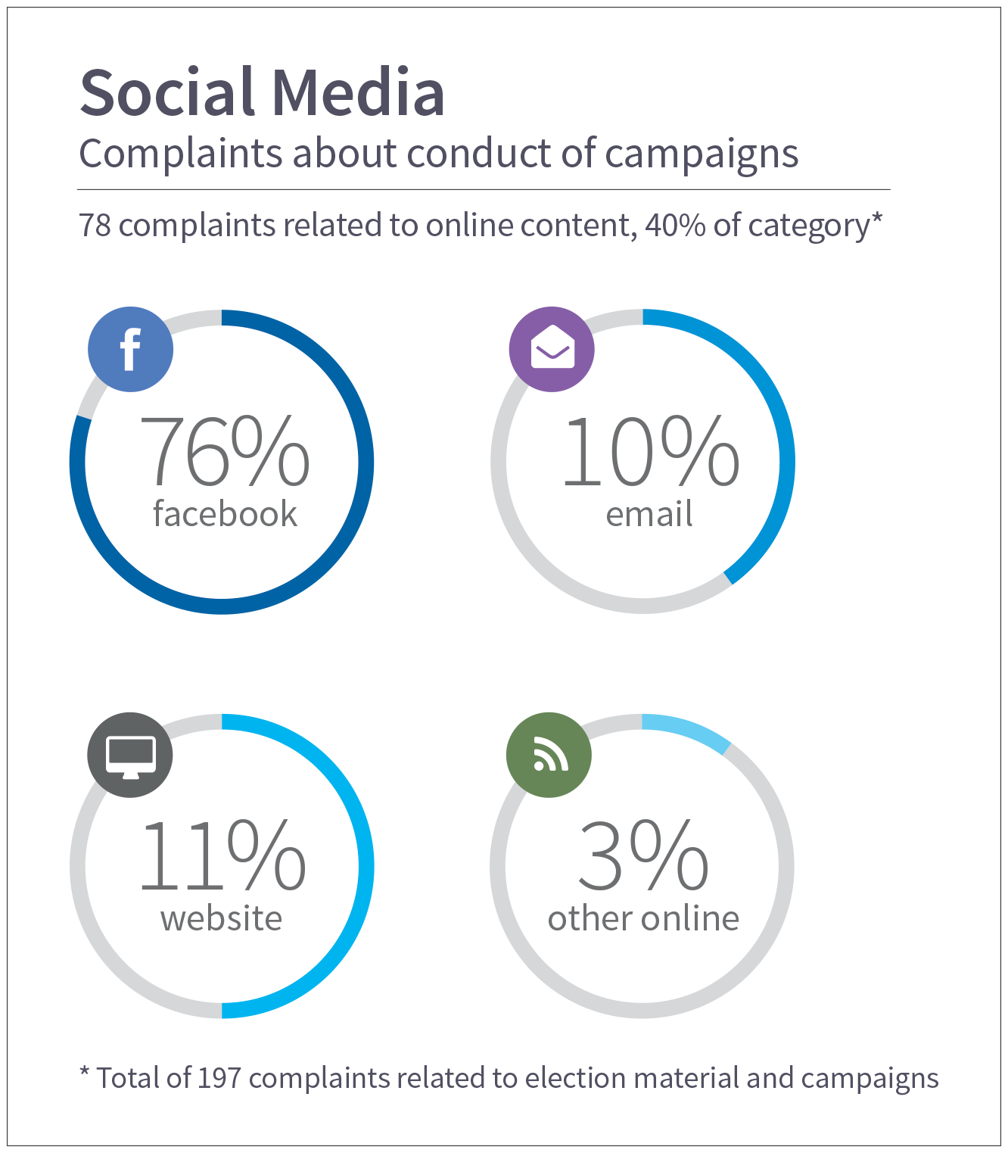

*Figure 3. Complaints made about campaign material on social media*

2 [*Evans v Crichton-Browne*](https://jade.io/article/66896) *(1980) 147 CLR 169*

These figures show that social media’s growing impact during 2016 elections, and while this technology continues to provide an economical way for candidates with limited financial backing to reach the electorate, it can produce challenges for existing legislation.

The legislation, as it stands, does not cater for the fast and fluid social and new media forums. Many enquiries received by the Inspectorate related to Twitter and whether tweets constituted election material that was required to be authorised. The same issues arose with Facebook, and several other formal complaints were about the use of group emails. With the continuing expansion of the medium, the Inspectorate supports a review of the need for the current laws or a tailored legislative approach for social media uses.

#### Outcomes

During the 2016 election period, the Inspectorate applied expertise and dedicated resources to maintain the integrity of the polls. As a result of this work, the Inspectorate was able to initiate two prosecutions for unlawful nomination for the City of Melbourne. It was also able to identify and remove two candidates, who were found ineligible to nominate in the elections, prior to election day and protect the integrity of two ballots.

The Inspectorate provided, and continues to provide, post-election education and guidance to all Victorian councils, and in a number of cases that involve low-level offences under the Act, has issued formal warnings. At the time of writing, several serious matters are under thorough investigation by the Inspectorate, which may result in additional prosecution cases.

# Pre-election work – what was achieved?

## Following the 2012 elections there were key legislative changes made to the Act concerning election period policies and candidate eligibility. This led to the Inspectorate conducting two reviews ahead of the 2016 election period to assess compliance with those amendments.

#### Election period policy review

During the 2012 elections, the Inspectorate received and assessed more than 20 formal complaints regarding conduct that allegedly did not adhere to the election period policy. Many of these complaints related to the use of council resources, or the use of council positions for election campaigning.

These incidents of councils not adhering to election period [caretaker] policies during the 2012 elections, coupled with new legislative requirements, guided the Inspectorate to undertake a comprehensive analysis of an election period policy at each council in 2016.

The purpose of the election period policy is to set out and define how councils will ensure their internal procedures adhere to the requirements of the Act. The policy is the council’s way of setting the legislation into practice and providing specific guidance to staff, councillors and candidates. The policy is public for the purpose of providing knowledge, transparency and information to the community.

Each council was required to adopt an election period policy by 31 March 2016 that included the following provisions:

* preventing inappropriate decisions and misuse of resources,
* limiting public consultation and council events, and
* equitable access to council information.

#### What we did

To support the legislative changes, and in preparation for the upcoming 2016 elections, the Inspectorate carried out a review of an election period policy at each council.

The Inspectorate collected relevant information and tested councils against the requirements of section 93B of the Act which required that each council:

* had an election period policy
* ensured each policy adhered to relevant electoral provisions of the Act
* made the election period policy public
* provided the policy to all candidates.

Highlighting the importance of the policy, to verify that the electoral provisions in the Act were contained in each council’s policy, the Inspectorate ensured that thorough processes were developed and then followed by each council prior to the election period commencing.

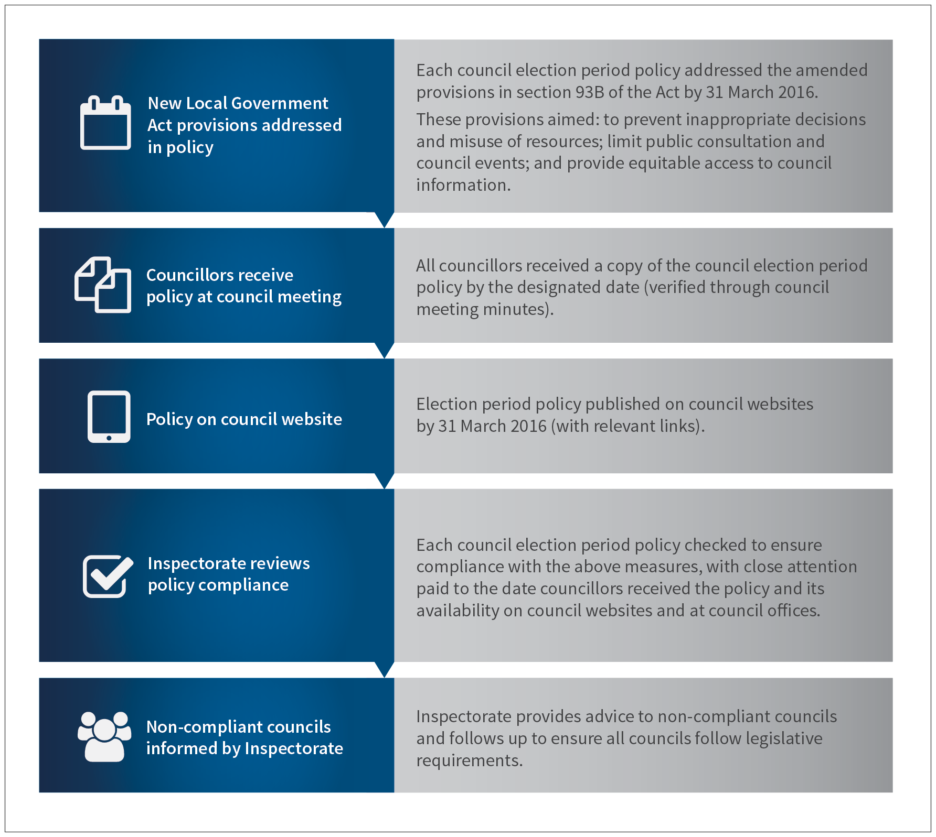

*Figure 4. Process for election period policy, from amendments to audit outcome*

#### What we found

When the review was completed and after following guidance from the Inspectorate, it was found that all councils were compliant in meeting the Act’s requirements.

It was pleasing to note that all councils had adopted an election period policy, and most had displayed the policy on their website. The Inspectorate also assisted the councils to ensure that the policy was appropriately published on their websites. Although not a requirement, the Inspectorate noted that some councils had specifically provided the policy to nominating candidates as part of candidate information packs, which was a very positive step.

#### Guidance and education

To support councils, councillors and candidates to understand and meet the requirements of the amended legislation, the Inspectorate produced a sector-wide Election Period Policy Report. The report included analysis of the review findings and clear guidance on:

* council policies providing clear instructions stating that councillors are not to use appearances at public events for the purposes of electioneering
* council policies stating that no electoral material is to be placed on council websites or social media during the election period
* councils including the election period policy in information packs provided to nominating candidates
* identifying model policies from various other councils.

The report is available from the Inspectorate's website on the 'Reports and newsletters page'3. In addition, the Inspectorate shared good practice examples4 sourced through the review, such as City of Whitehouse’s election policy, with the rest of the sector.

*“The City of Ballarat utilised the Election Period Policy Review document extensively leading up to and throughout the election period. In particular, the review document provided simplified and accurate guidance on compliance which helped to clarify the legislation and processes required. It was also used as a checklist for training staff and to ensure our local policy was appropriately distributed.”*

*Justine Linley, CEO, City of Ballarat*

*“Those of us who work in governance know how challenging it can be. I am appreciative of the auditing, monitoring, information sharing and guidance offered by the Inspectorate. Such services enable the lifting and maintenance of a high standard of compliance, transparency and integrity in the sector and promote local government in a positive way.”*

*Tony De Fazio, Manager Civic Services, City of Whitehorse*

#### What was the outcome?

Following amendments to the Act in 2015, and through continued work informing councils of these changes, the Inspectorate noted a significant reduction from 2012 in substantiated matters arising from complaints about the use of council resources by sitting councillors.

This reduction demonstrates how the sustained effort of informing and educating can improve community knowledge of the roles and responsibilities of councils, councillors and candidates during elections. Proactive work by the Inspectorate has also increased compliance before and during elections, which therefore reduces the need for reactive complaints investigations.

1. [*http://www.vic.gov.au/lgici/reports-and-newsletters.html*](http://www.vic.gov.au/lgici/reports-and-newsletters.html)
2. [*http://www.vic.gov.au/lgici/quality-and-compliance/best-practice-in-council-policies.html*](http://www.vic.gov.au/lgici/quality-and-compliance/best-practice-in-council-policies.html)

#### Candidate eligibility review

During the 2012 election period, the Inspectorate looked at issues with the eligibility and nomination criteria as set out by the Act. As a result of this work, the Inspectorate was able to identify gaps in the nomination process.

Following the 2012 elections, the Inspectorate made a submission to the Local Government Electoral Review which ultimately resulted in amendments to eligibility requirements in the legislation relating to the personal and financial probity of candidates. The legislation was also amended to remove the ability for candidates to nominate remotely using a statutory declaration, instead requiring all nominees to submit their nomination in person to a VEC returning officer.

In determining eligibility to stand for council, the legislation generally outlines what is so undesirable as to warrant disqualification. The assessment of skills, qualifications and other qualities, considered to be important to the electorate, is ultimately made by the constituency at the ballot box.

More than 2100 candidates stood for council during the 2016 elections. To assist in maintaining the integrity of the democratic electoral process, the Inspectorate sought to identify whether candidates had broken the law when declaring their eligibility.

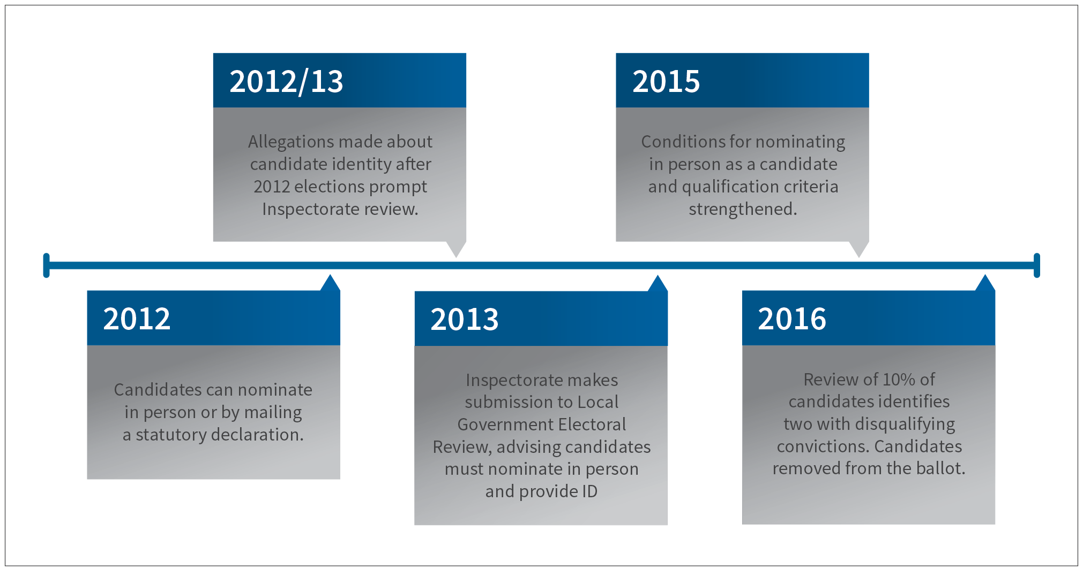

*Figure 5. Timeline of changes and outcomes from candidate eligibility work*

#### What we did

The current legislation states that a signed declaration, in the presence of the VEC returning officer, is considered sufficient evidence in support of a nominating candidate’s eligibility. The declaration form attests to their qualification, including their entitlement to vote and be elected. No further identification, asset tests, or criminal checks [police records check] are required to support a candidate nomination. The Inspectorate conducted a candidate eligibility audit in which a sample of approximately 10% of candidates was assessed for any disqualifying financial or criminal history.

The sample size was determined by selecting a random number of candidates, and targeted inclusions where intelligence or information was used to identify specific candidates. The volume of candidates did not allow for the Inspectorate to conduct a full review of every candidate.

As part of the review, the Inspectorate ran eligibility checks on the personal and financial probity of each candidate in the sample group.

#### What we found – analysis of the review

The Inspectorate found two candidates that were ineligible to nominate in the 2016 elections and therefore they were removed from their respective ballots, albeit after ballot papers had been prepared.

The review highlighted, that with such a short timeframe between the closure of the nomination period and printing of ballot papers, it is not viable for an agency to check all candidates for eligibility and intervene where required. The system relies on candidates to firstly understand the eligibility criteria and then correctly and honestly complete the nomination form, self-assuring their nomination information. This process is vulnerable where, as in the case of the two candidates identified as part of the sample reviewed in 2016, there was a misunderstanding of the disqualifying criteria or, as in the case of the 2012 candidate who was convicted of unlawful nomination, there was an intention to deceive the electorate.

#### Points for consideration

This raises an important question as to whether or not to place additional impost on candidates who wish to nominate for elections. Or, in the case of personal and financial probity whether or not to ask candidates to demonstrate, at the time of nomination, if they are able to be elected and therefore ensuring the eligibility of the candidate field. In general terms, should it be a requirement for candidates to produce a police and bankruptcy check at the time of nomination to prove eligibility?

The argument to not place additional impost on a nominating candidate is based on the premise there is a risk that eligible candidates might be prevented from nominating because their decision to contest is made too late for the relevant check to be obtained. It would also mean nominating for the office of councillor in Victoria would require greater effort by a candidate than in any jurisdiction in Australia or in other words, an extra hurdle.

Another view would be that council elections are held on a fixed date and known four years in advance, with the nomination period open for a five-day window just prior to the election period. Noting this timeframe, police and bankruptcy checks, which are valid for six months, could be obtained by a potential candidate within two days of application. On this basis, there is little risk that an eligible and genuine candidate would be prevented from nominating if this requirement was in place. In terms of the greater effort or additional hurdle that is required by the nominating candidate, that is a question of balance between the importance of the office of councillor and the steps required to nominate.

In the *Local Government Electoral Review*, the Inspectorate made a submission to strengthen the nomination requirements and ask candidates to provide evidence of personal and financial eligibility at the time of nomination. This was based on the consequences that false or unlawful nominations can make on the system, with significant legal, financial, personal and reputational costs to remedy or unwind elections when this occurs. The risk is where an ineligible person may be elected or where the preferences of an ineligible person may determine the outcome. This was largely prevented in the two municipalities where the ineligible candidates were identified as part of the review; noting not all candidates were assessed in that review.

The Inspectorate maintains that candidates, along with signing the declaration form, should submit completed police and financial probity checks and provide supporting photographic identification when nominating for candidature.

Importantly, the Inspectorate does not consider this process would deter any genuine candidates from nominating for the office of councillor and may have the added benefit of causing non-genuine or ‘dummy’ candidates to reconsider.

An additional benefit of this consideration would be the provision of two documents at the time of nomination to verify the entitlement address of the candidate. While it is accepted that the entitlement is related to the electoral roll, additional documents to verify the address may have prevented the two current prosecution cases, two Municipal Electoral Tribunals and several ongoing investigations relating to unlawful nominations emanating from false entitlement addresses.

In essence, the Inspectorate is of the view it is better to have a gatekeeper checking eligibility before candidates are accepted into the electoral process, rather than have harm caused to the system when unlawful nominations are detected after the ballot is held.

**Case study: Council election candidates retired**

Two candidates were retired from the 2016 Victorian council elections as a result of enquiries by the Inspectorate.

Once the nomination period for candidates closed on 20 September, the Inspectorate assessed a sample of candidates to ensure they met the requirements of the Local Government Act 1989.

As a result of the review, two candidates were removed from their respective ballots. Inspectorate enquiries revealed the two candidates were not eligible to become councillors after running afoul of the disqualification provisions of the Act.

The removal of these candidates was essential to protect the integrity of the elections.

# Local government laws for media during elections

## The *Local Government Act 1989* contains specific laws for media. During the 2012 elections the Inspectorate investigated five media outlets, and given the relatively low-impact of the offences, they were given formal warnings. By comparison, following the Inspectorate’s education campaign in 2016, only one case was substantiated for a media outlet contravening the electoral laws.

The media played an important role in providing information in the lead-up to the 2016 elections and alongside this role comes certain responsibilities. The Inspectorate contacted Victorian media outlets to remind them of the particular laws in the Act relevant to them. These laws govern the publication of council and candidate-related material and guidance material to ensure candidates and the media did not unknowingly commit an offence under the Act. Only one complaint relating to a media outlet contravening the electoral laws was received and ultimately substantiated. This resulted in a warning being issued.



*Figure 6. Media coverage from across Victoria during the 2016 council elections*

Many other media-related enquiries were about the lack of information around candidates and who they were aligned with. The media [particularly local media] provided opportunities for candidates to put their case forward for election. Moreover, the media created an important forum for statements or claims to be challenged, verified or debunked.

Overall, the Inspectorate found reporting was particularly strong in rural and regional media as well as in suburban newspapers during the 2016 election period.

# Campaign donation returns

## Following the declaration of elections, the Inspectorate focusses on several key compliance requirements to ensure ongoing integrity and transparency in the sector. The requirements relating to Campaign Donation Returns (CDRs), including the submission of the return and the accuracy and completeness of the return, are an important part of this work.

A CDR is a record of gifts, if valued at $500 or more, received by election candidates for use in their election campaigns. Section 62 of the Act requires all candidates to submit a CDR to the Chief Executive Officer (CEO) of the council within 40 days after the election has closed. The CEO is then required within 14 days to submit to the Minister for Local Government a list of all candidates who nominated and a list of all candidates who submitted a return. Failure to lodge this return by the due date, or if false information is provided on the return form, are considered offences under section 62 and carry penalties up to $9,327.60.

The Inspectorate considers transparent disclosure of CDRs by all candidates during the election period as fundamental to maintaining the integrity, of not just the elections, but more importantly the future decision making and governance of councils.

In 2012 the Inspectorate sent relevant information to all candidates with outstanding CDRs. Despite ample documentation and repeated reminders, 19 prosecutions were carried out. Overall these resulted in 16 findings of guilt, two convictions, $5650 in fines, the awarding of $19,229 in costs, a $1000 to court fund, five good behaviour bonds and one community work order.

#### What we did

During the 2016 election period, the VEC sent out CDR process material to all candidates running in the elections as part of its candidate information kit. The VEC kit included clear information about lodgement plus deadlines, an election CDR pro forma and an explanatory leaflet provided by the Inspectorate. The leaflet contained comprehensive information regarding CDRs and the legislative timeframe for submission to the CEO.

In November 2016, the Inspectorate sent an additional reminder to all candidates, providing clear and concise advice about their responsibility to submit a return and the key lodgement deadlines.

#### What we found

Despite the strong proactive work of the Inspectorate and the VEC, the CEO written reports indicated that 288, or more than 13% per cent of all candidates, failed to submit their returns to the CEO by the 1 December due date.

The CEOs reports indicated that from the 1 December deadline until their advice to the Minister, 40 of the 288 who failed to submit a return on time, did so after the deadline.

#### What was the outcome?

Following advice received from the CEOs, the 40 candidates, who were late in submitting their CDRs, were issued with a formal warning for submitting a late return. These 40 candidates were in effect committing an offence under the Act.

However, the Inspectorate reviewed the details of these, and on the basis they had ultimately submitted the CDR, candidates that had not been previously charged or warned over *Local Government Act 1989* offences, and were relatively low-risk, all received formal warnings.

The Inspectorate will soon commence follow-up action of the 248 candidates who had not submitted a return at the date of each CEO’s written report to the Minister. Depending on the responses received, the Inspectorate may ultimately undertake prosecution action.

Importantly, the Inspectorate will undertake a review of a sample of the submitted returns to scrutinise the content for accuracy and any omissions. This work underpins the integrity of the sector and ensure councils decision making in the future is both transparent and accountable.

# Appendix A: Complaints and relevant Act provisions

The complaints refer to the following sections of the *Local Government Act 1989*.

Section 11 Entitlement to be on voters' roll

Section 22 Voters' roll preparation Section 24C Misuse of voters' roll Section 28 Candidate eligibility

Section 29 Disqualification of candidate Section 41 Holding of an election Section 52 Unlawful nomination Section 54 Interfering with rights

Section 55 Authorisation of election material

Section 55A Statements likely to mislead or deceive a voter in the casting of their vote

Section 55B Heading of electoral advertisements

Section 55C Authors to be identified

Section 55D Prohibition on Council

Section 58 Offences relating to ballot papers Section 58A Interference with postal ballot materials Section 59 Bribery, treating and undue influence

Section 62 Election campaign donation returns by candidates

Section 76D Councillor misuse of position Section 78 Indirect interest by close association Section 79 Disclosure of conflict of interest Section 80 Exemption by Minister

Section 81 Register of interests

Section 238A False written declaration

Other Matters not covered by the Act or yet to be assessed

## Local Government Investigations and Compliance Inspectorate



### **Encouraging higher standards of integrity, accountability and transparency in local government**

Level 27, 1 Spring Street, Melbourne, Vic 3000

 [inspectorate@lgici.vic.gov.au](mailto:inspectorate@lgici.vic.gov.au)

 1800 469 359

 [www.lgici.vic.gov.au](http://www.lgici.vic.gov.au/)